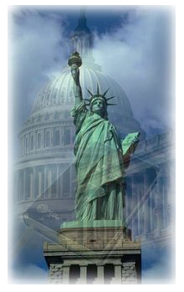
Greater Lodi Leadership Prayer Breakfast
2923 Applewood Drive, Lodi, CA. 95242 www.leadershipprayerbreakfast.com

Dear Potential 2017 Prayer Breakfast Sponsor,

Greetings! We hope this finds you well. On behalf of the entire Greater Lodi Leadership Prayer Breakfast Committee, we want to extend our heartfelt thank you for your consideration to sponsor this year’s annual Leadership Prayer Breakfast.
The Breakfast will be held on September 21, 2017at the Woodbridge Golf and Country Club, from 6:00 am to 8:00 am. We pray that it will provide encouragement and inspiration to all who attend. This year’s keynote speaker is Donnie Moore, the chairman of Donnie Moore Ministries (please visit our website for Donnie’s biography and website link).
We hope you will plan on sponsoring this year’s annual Prayer Breakfast. Your involvement will go a long way in promoting Christian leadership, goodwill and prayer in our community. We cannot do it without faithful business & corporate sponsors like you!
Very Truly Yours,
Denny Callahan Frank Ruiz Kerry Suess
Co-Chair, 2016 Co-Chair, 2016 Sponsor Coordinator
(209) 329-1242 (209) 810-0072 (209) 327-5347
dcallahan72@comcast.net frank@cidsol.com kerry@kerrys.org
We are asking for your consideration in participating in this year’s event as either a Business & Corporate Sponsor, for $300 (1 table of 8, table signage, listed in program and on website for the year with a link to your website), or as a Major Sponsor, for $500 (above benefits plus mention by name at the breakfast and in all advertising for event). Individual tickets are sold for $25 each. Reservations can be made by completing and returning the information below, by visiting our website at http://www.leadershipprayerbreakfast.com, or by calling one of the phone numbers above. Please make your check payable to the Leadership Prayer Breakfast and mail to 2923 Applewood Drive, Lodi, CA 95242.
Please reserve table(s) and print table signage as follows: ______________________________________________
Mail tickets to: __________________________________________________________________________________
My contact information is:__________________________________________________________________________
Please link our website to yours (please provide web address):_____________________________________________
The Greater Lodi Leadership Prayer Breakfast is patterned after the Annual National Prayer Breakfast in Washington D.C., and
OUR PLANNING COMMITTEE IS 100% VOLUNTEER.

